SUBMITTED BY-

ASMITA JAIN

0901EO201017

SUBMITTED TO-

PROF. APRAJITA KUMARI

MADHAV INSTITUTE OF TECHNOLOGY AND SCIENCE, GWALIOR

**SENSOR TECHNOLOGY LAB 220202**

**EXPERIMENT -3**

**AIM:**

To draw to characteristics of a photoconductive cell.

**THEORY:**

**OPTICAL SENSORS**- An optical sensor converts light rays into an electronic signal. The purpose of an optical sensor is to measure a physical quantity of light and, depending on the type of sensor, then translates it into a form that is readable by an integrated measuring device.These sensors are used mainly for contact less detections.

There are many types of optical sensors which include photoconductive cell, photovoltaic cell , photodiodes etc.

**PHOTOCONDUCTIVE CELL**- It is used in measuring resistance by converting the illumination fall on the cell into resistance change.

**Photoconductive effect**- The light striking provide sufficient energy to cause electrons within the material to break away from the atom. These free electrons and holes are created moves freely and increase conductivity and hence decrease the resistance.

Cadmium sulfide (CdS) and cadmium selenide (CdSe) are generally used to make photoconductive cell.

Dark resistance- When the cell in not illuminated the resistance goes over 100 kilo ohm, which is known as the dark resistance.

There are various uses of a photoconductive cell as a sensor like in street light, motion sensing lights and cameras, in alarm systems etc.

**CIRCUIT DIAGRAM:**

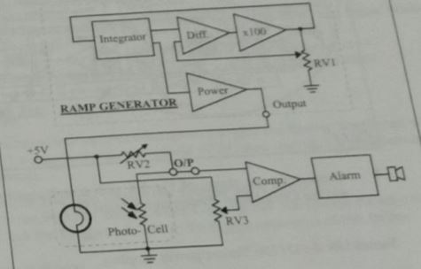

Circuit symbol of photoconductive cell-

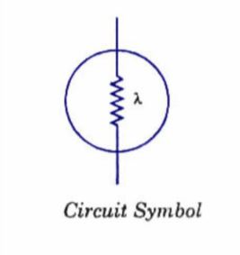

**GRAPH:**

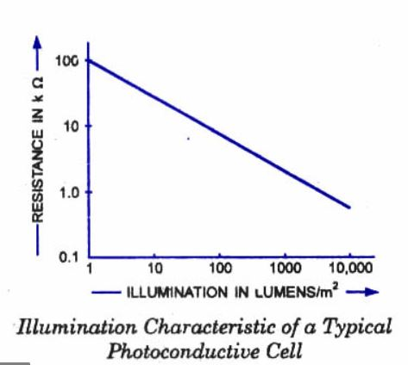

**RESULT:**

Hence, we have studied the working principle of a photoconductive cell and its characteristic.